CS251 Statistical Computing

**HOP01C: Git and GitHub**

23/6/2020 Developed by Aya Khalil

10/16/2020 Reviewed by Shanshan Yu

School of Technology & Computing @City University of Seattle (CityU)



**Learning Outcomes**

* Understand the concept of version control system (VCS)
* Install Git for Windows and Mac OS

**Before you start**

Version control system (VCS) makes it easy to store different versions of the project (without any fixed rules, time, or rules). You can easily restore an earlier record and compare the content with the current data to find the differences. In addition, it also an effective tool to cooperate with many other people in the same project. In this module, we will learn about one of the most popular VCS, which is Git and GitHub.

First of all, Git and GitHub are not the same things. Git is a VCS, while GitHub is a hosting server for software development version control. The way Git works is that it creates a **repository** to store each version of the project every time developers modify or add some features into the project. Developers use Git through terminal or command line.

However, Git only allows you to control your project version on your local machine. Therefore, if 2 or more people are working on the same project, how do we connect the works of all the members? That is why we need a hosting server GitHub.

To learn more about Git and GitHub visit:

<https://codeburst.io/git-and-github-in-a-nutshell-b0a3cc06458f>

<https://git-scm.com/book/en/v1/Getting-Started-Git-Basics>

<https://www.youtube.com/watch?v=SWYqp7iY_Tc>

**For Windows OS**

1. Visit <https://git-scm.com/download/win> and click on Download for Windows

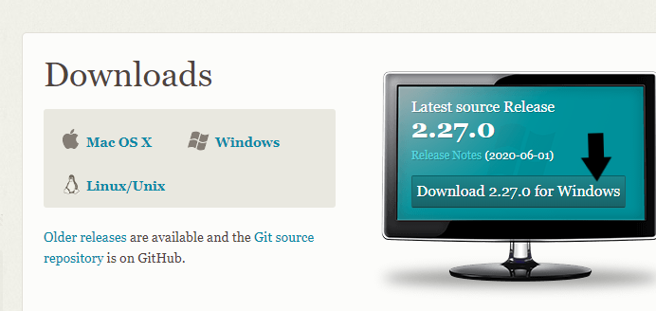

1. Open the file that was downloaded.
2. Choose yes to allow Git installation on your PC.

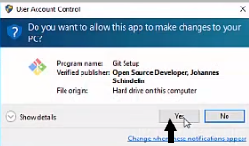

1. Go through the installation and choose the default options.

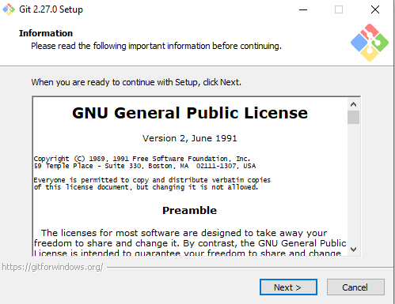

1. For this one, we will choose the last option to give us extra commands to use.

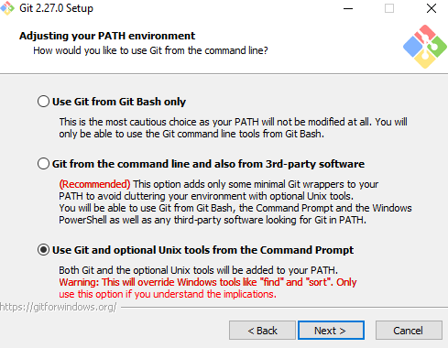

1. For the rest of the installation, choose the default options.
2. Uncheck View Release Notes because we do not need it.

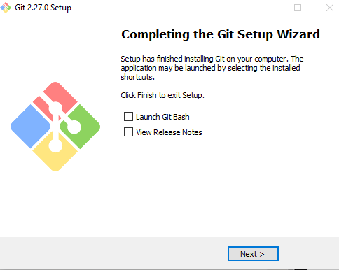

Once the installation is completed, open the cmd

* In the search bar, type cmd, and choose Command Prompt.

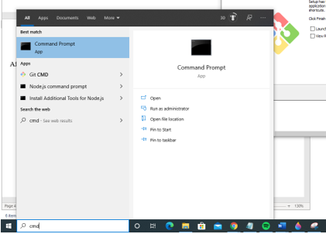

In the cmd, type git –version, you will see git version 2.27.0

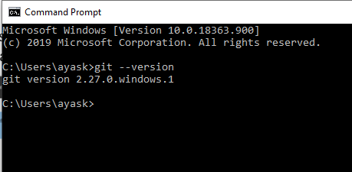

***Note: If you got the following error***



**Then,**

you need to add the PATH of Git into the Environment Variables

1. In the cmd, type where Git

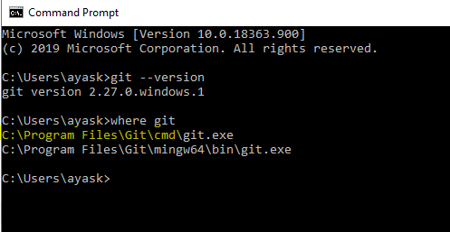

Copy the first one and add it to the environment variables

To open the environment variables

* In the search bar, type environment variables and choose Edit system environment variables

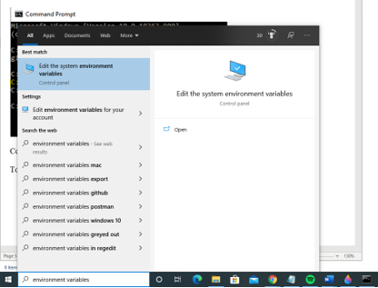

* Choose Environment Variables

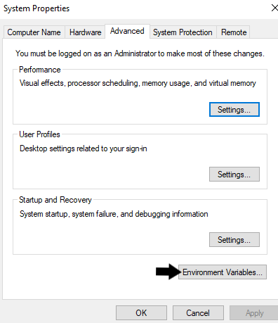

* In the System Variables, choose Path, then select Edit Button
* 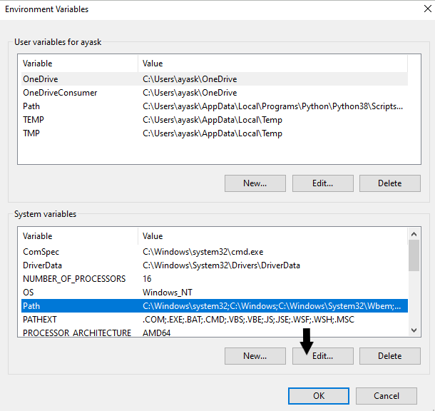
* Choose New, then Paste the Git location that you copied from the cmd

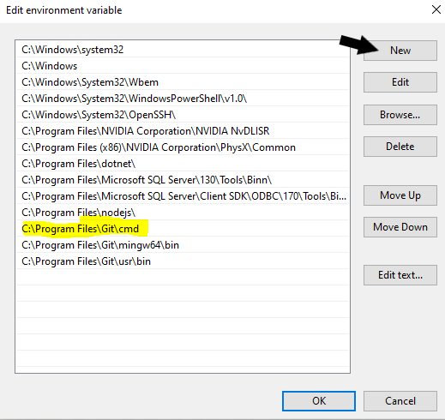

**Close the cmd**, then open it one more time and type git –version to make sure that the Git installed successfully

**For Mac OS**

There is more than one way to install Git on Mac

**First way**

Type in the terminal

git –version



**If you got an error and Git is not recognized by your machine, then try the next way.**

**Second way**

Follow the steps in the link <https://sourabhbajaj.com/mac-setup/Homebrew/> to install homebrew if you don’t already have it then type the following command in the terminal.



Install Homebrew

For more information about what brew can do, visit the following link <https://brew.sh/>

* Open the terminal and type the following /bin/bash -c "$(curl -fsSL https://raw.githubusercontent.com/Homebrew/install/master/install.sh)"

/bin/bash -c "$(curl -fsSL https://raw.githubusercontent.com/Homebrew/install/master/install.sh)"

* If it asks you to press RETURN to continue, then press RETURN/Enter button.

* Then choose install

After the installation is done, type the following in the terminal to install Git

